CURRICULUM VITAE

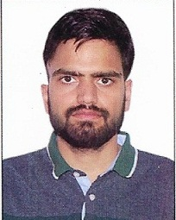
Name HARJINDER SINGH
  - Mobile No: +919882334647
E-Mail: harjinder033@gmail.com

Vision
My vision is to create a positive environment for students to learn essential or basic academic knowledge skills and character development. I accept, understand, and open myself to the ideas and beliefs of others to help them to accomplish their goals.

Academic Qualification and Achievements

CSIR-JRF 2020
SET 2017,2018
GATE 2018
Inspire Holder

PhD (pursuing)
2021
Department of Mathematics and Statistics, Himachal Pradesh University Shimla
Topic of Research: Hydrodynamic and Hydromagnetic stability

M.Sc (Maths)
2015-2017
Department of Mathematics and Statistics
Himachal Pradesh University Shimla
Division: First

B.Sc(non-medical)
2012-2015
GDC Amb(Himachal Pradesh University Shimla)
Division: First

Conference and Paper Publications
- Paper entitled “On Exchange Principle in Multicomponent Convection with Viscosity Variations” at the 2nd International Conference on Mathematics in Space and Applied Sciences (ICMSAS-2023) Organized by the Department of Mathematics, Govt. College Hamirpur on 3rd - 4th March 2023.

- Paper entitled “Upper Limits to the Complex Growth Rate of Rotatory Hydrodynamic Multicomponent Convection with Variable Viscosity” at the International Conference on Recent Advances in Mathematical Sciences (ICRAMS-2023) Organized by the Department of Mathematics & Statistics Himachal Pradesh University in collaboration with Himachal Mathematical Society on 29th - 30th March 2023.

